**Introduction**

In order to optimise the growth of the ice formation throughout the winter, and understand its melt in the spring and summer, it is crucial to understand how various environmental parameters influence the freeze and melt dynamics.

I have created a data analysis and modelling pipeline to elucidate the effect of the different parameters measured by the weather station namely temperature, relative humidity, wind speed. Using machine learning algorithms, I have matched these parameters to changes in the height of the stupa, measured from images snapped by the same weather station (height was manually measured in pixels from the images, and extrapolated the pixel dimension to a metric one based on a few reference frames). Also periods of fountain water flow were determined using the images. The timelapse video can be found [here](https://youtu.be/RqA4yrPZghE).

Unfortunately, the results suffer from a low sample size in the measurements, and a data deficit especially due to irregular water supply and unavailability of fountain water discharge data.

**Val Roseg Ice Stupa**

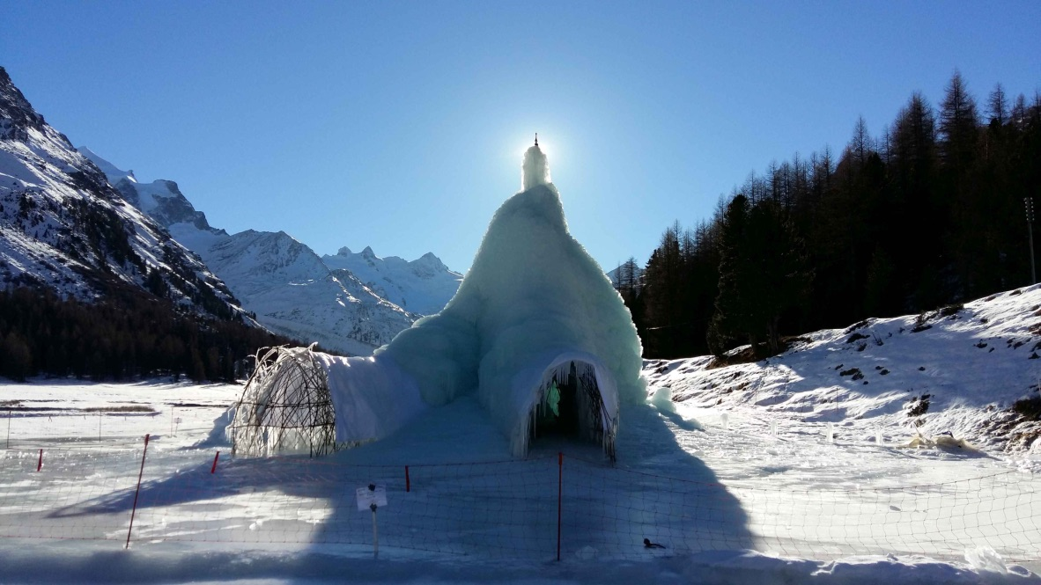

**Methods and data**

All the data used comes from Utrecht’s Automatic Weather Station installed by Wim. There was also a high resolution timelapse camera as part of it which took day time photos every 2 hrs from 9am to 4pm. The weather data with 5571 records spanned from 17th November to 7th July. The timelapse imagery with records was selected upto 8th April as the Ice Stupa wood skeleton was exposed by then. All the files of this project can be accessed at [Github](https://github.com/Gayashiva/Val_Roseg).

To extract the height in metres, every peak point of the timelapse was marked and then the height was estimated. The reference image shown below was used to map this data into height assuming the person to be 6 ft tall.

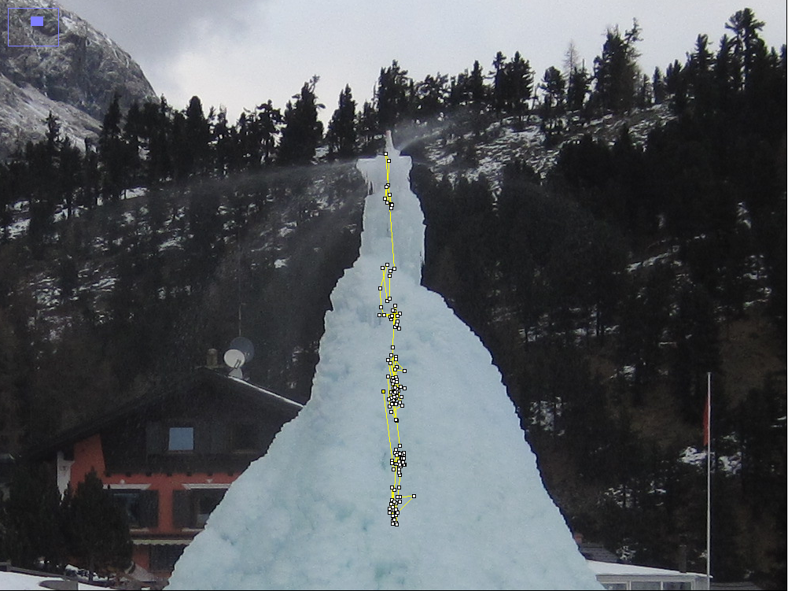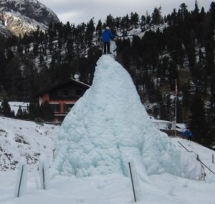

Figure Showing the manual selection of peak points and the reference image to map pixels to metres

**Data selection and analysis**

Therewere 3 steps to this each with their own online notebook:

1. [Data extraction and selection from the timelapse imagery and AWS](https://github.com/Gayashiva/Val_Roseg/blob/master/notebooks/data_refining.ipynb)
2. [Fountain Water flow analysis](https://github.com/Gayashiva/Val_Roseg/blob/master/notebooks/Water_IO.ipynb)
3. [Multivariate Regression Analysis](https://github.com/Gayashiva/Val_Roseg/blob/master/notebooks/Analysis.ipynb)

Please refer the respective notebooks for full details of the process.

**Model results**

**Precipitation data Day and night separation, water used, freezing efficiency,**











growth rate below 10 is snow or error abrupt pipe extensions and freeszing and breaking



**Discussion**

**Thermography, discharge measurements, fountain profile, melt water collection, evaporation, south side, pixel area, pixel wise melt probability, internal microclimate, fixed height**